**CITIZEN AI –INTELLIGENT CITIZEN ENGAGEMENT PLATFORM**

* **TEAM MEMBERS:**
* PRIYADHARSHINI M
* PRIYADHARSHINI P
* REKHA D
* REVATHY D

**CONTENTS**

* Project overview
* Pre-requisites

* Project workflow

**Activity-1:** Exploring Naan Mudhalvan smart internz portal

**Activity-2:** Choose a IBM Granite Model From Hugging Face

**Activity-3**: Running Application in Google Collab

**Activity-4**: Upload Your Project in GitHub

**PROJECT OVERVIEW**

This project aims to develop an advanced AI-powered digital assistant designed to enhance public awareness and safety at the city level. By leveraging the capabilities of large-scale language models, the system will analyze various datasets—including crime statistics, accident reports, and public safety indicators—to provide real-time, localized insights into security conditions within specific urban areas.

In addition to safety analysis, the system will serve as an accessible and reliable source of information regarding government schemes, policies, and welfare programs. By interpreting complex policy documents and official announcements, the AI assistant will simplify and communicate this information in a clear, conversational, and colloquial style, making it easily understandable for the general public.

**What is citizen ai?**

Citizen AI refers to artificial intelligence systems designed to act as responsible and ethical members of society. These AI systems are created not just to perform tasks efficiently, but to make decisions that align with human values, fairness, and societal norms. The idea behind Citizen AI is that as artificial intelligence becomes more integrated into our daily lives, it must act in ways that support human well-being. A Citizen AI should be transparent, explainable, and accountable for its actions. It must understand the cultural and ethical context of the society it serves. This includes respecting privacy, avoiding bias, and promoting inclusivity. Organizations building AI systems are now expected to treat them as digital citizens, with responsibilities similar to human citizens. This also means they must be trained on diverse and fair data. As AI takes on more roles in government, healthcare, education, and justice, the stakes are high. A misstep can cause harm to individuals or entire communities. Therefore, designing AI with ethical principles is critical. Citizen AI aims to ensure that technology uplifts humanity rather than causes harm. It encourages

collaboration between technologists, ethicists, and policymakers. This concept also promotes AI literacy among the public. If people understand how AI works, they can better trust and engage with it. Citizen AI promotes the idea of shared responsibility. Developers must ensure safety and fairness, while society must monitor and guide AI behavior. It also helps prepare future generations to coexist with intelligent systems. Ultimately, Citizen AI is about building trust between humans and machines. It is a vital step toward a future where AI contributes positively to human progress.

**Pre-requisites:**

* Gradio Framework Knowledge: [Gradio Documentation](https://www.gradio.app/docs)

* IBM Granite Models (Hugging Face):[Hugging face](https://huggingface.co/)

* Python Programming Proficiency: [Python Documentation](https://docs.python.org/3/)

* Version Control with Git:  [Git Documentation](https://git-scm.com/docs/git)

* Google Collab’s T4 GPU Knowledge: [Google Collab](https://www.geeksforgeeks.org/python/how-to-use-gpu-in-google-colab/)

**PROJECT WORKFLOW**

**Activity-1**: Exploring Naan Mudhalvan smart internz portal

**Activity-2**: Choose a IBM Granite Model From Hugging Face

**Activity-3**: Running Application in Google Collab

**Activity-4**: Upload Your Project in GitHub

Activity-1: Exploring Naan Mudhalvan Smart Internz Portal.

● Search for “Naan Mudhalvan Smart Internz” Portal in any Browser.

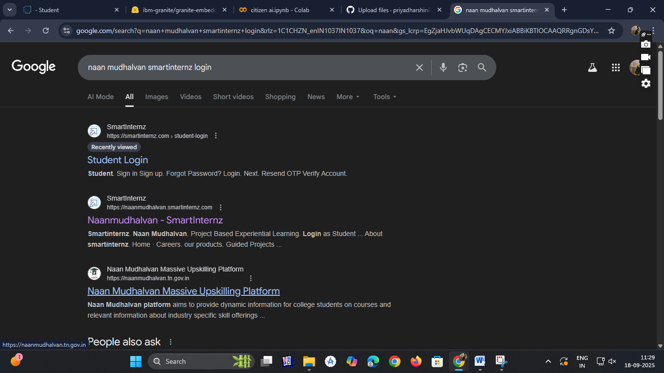

● Then Click on the first link. ([Naanmudhalvan Smartinternz](https://naanmudhalvan.smartinternz.com/)) Then login with your details.



● Then you will be redirected to your account then click on “Projects” Section. There you can see which project you have enrolled in here it is “ CitizenAI"

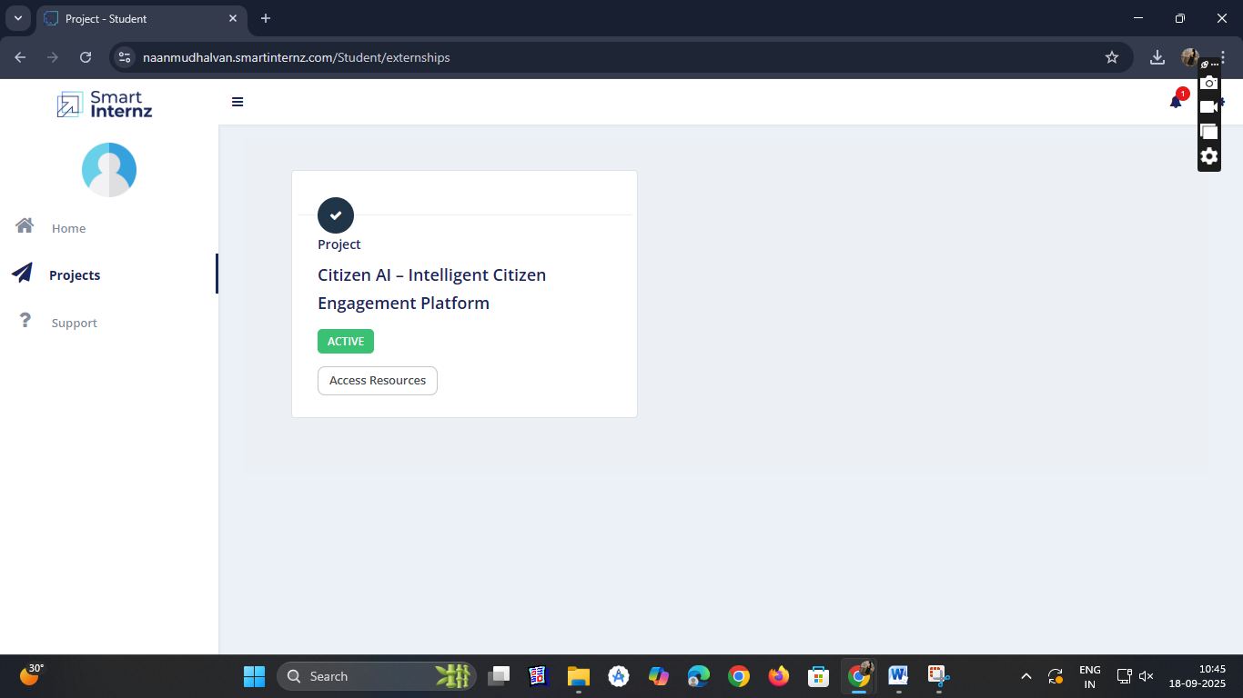

● Then click on “Access Resources” and go to the “Guided Project” Section

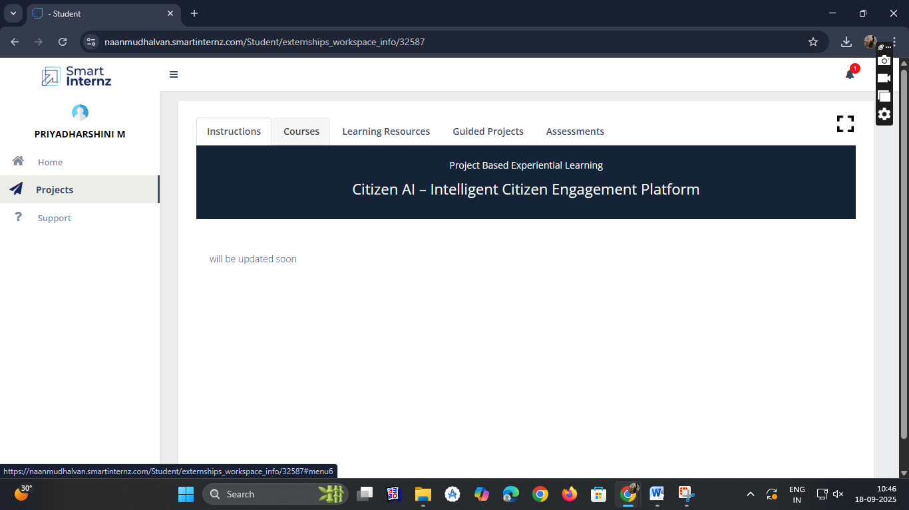

● Click on the “Go to workspace” section. Then you can find the detailed explanation of Generative AI Project using IBM WatsonX API key

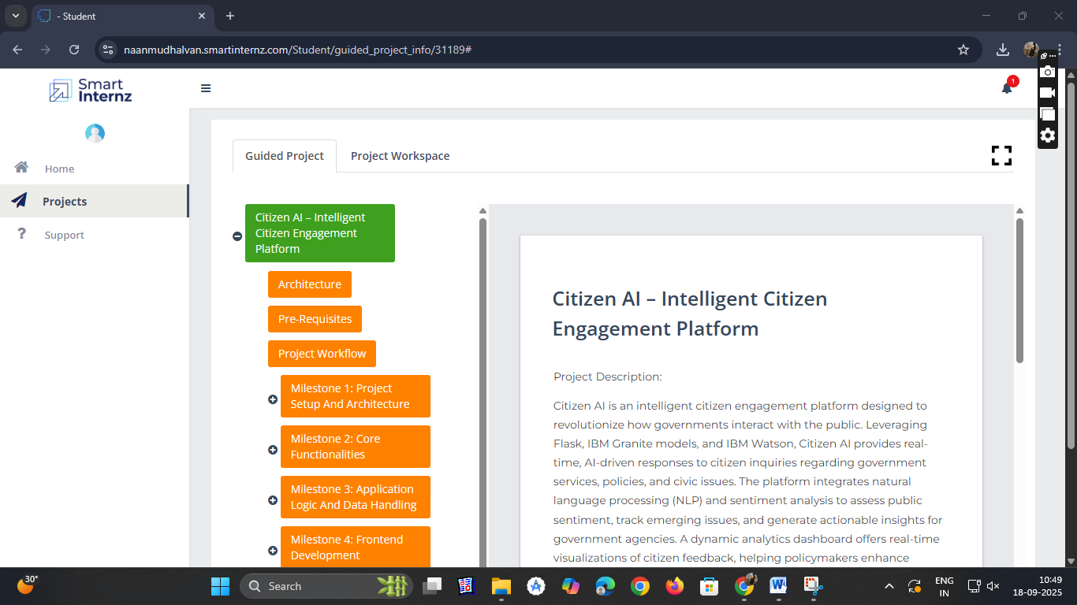

● Click on “Project Workspace”, there you can find your project progress and Place to upload “Demo link.

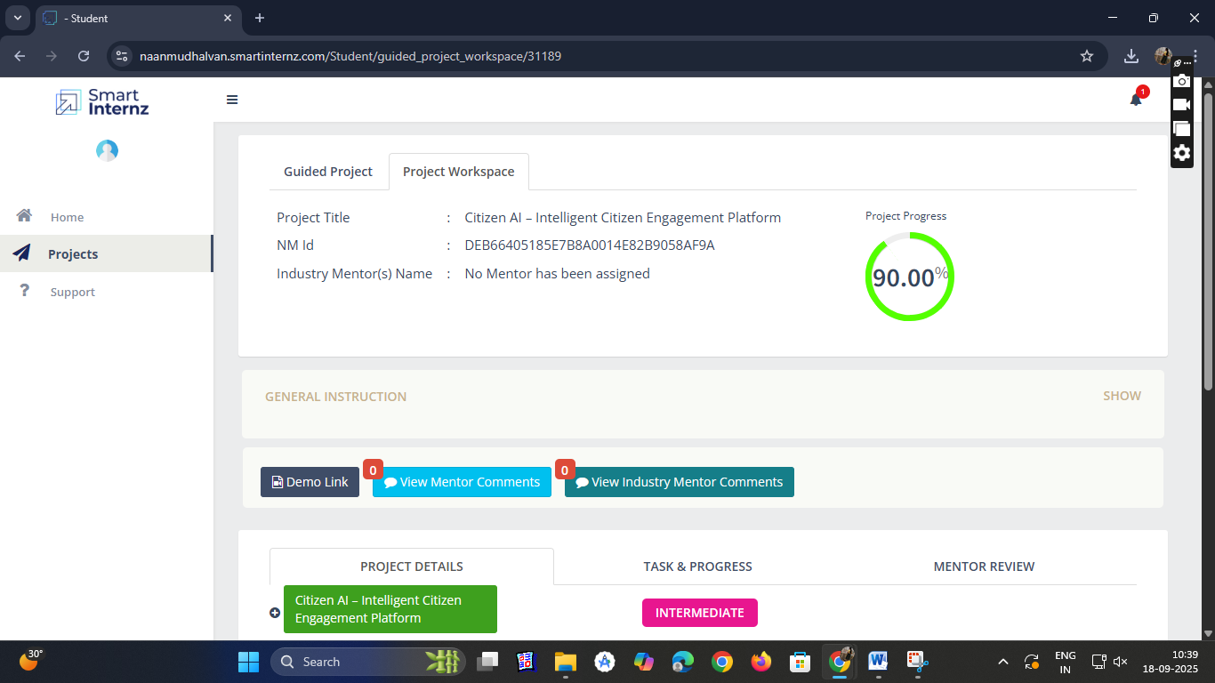

● Now we have gone through portal understanding, now lets find a IBM granite model from hugging face to integrate in our project.

Activity-2: Choose a IBM Granite model From Hugging Face.

● Search for “Hugging face” in any browser.

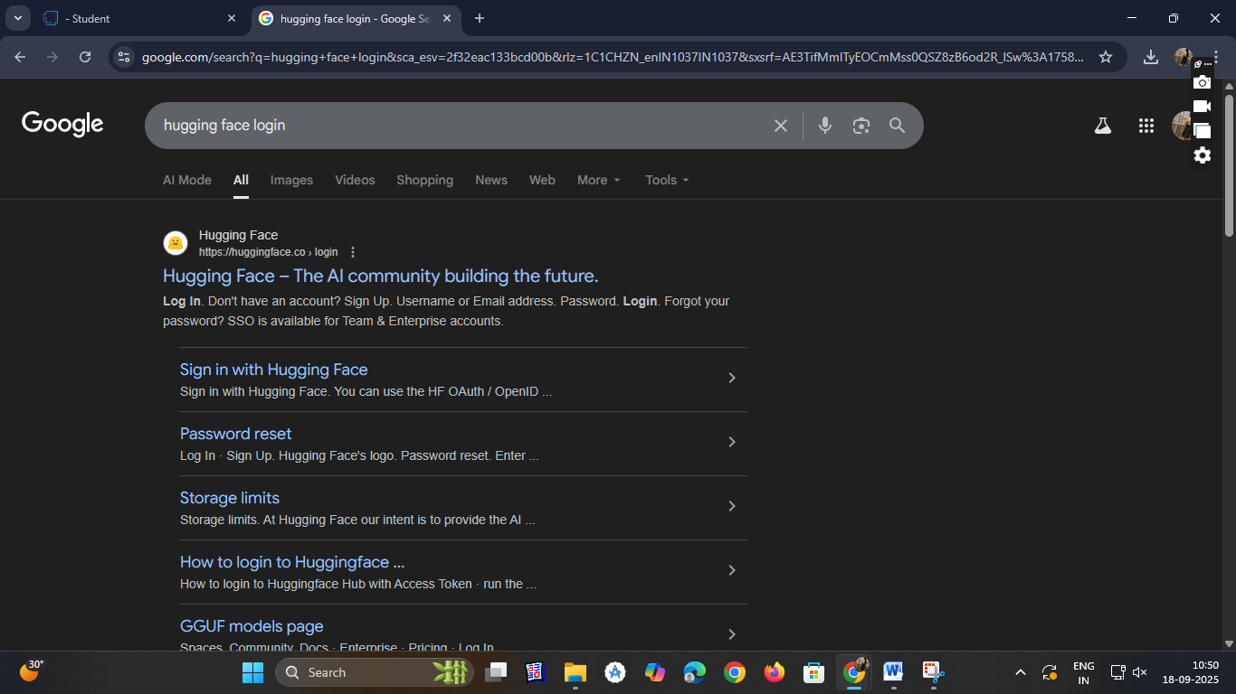

● Then click on the first link ([Hugging Face](https://huggingface.co/)), then click on signup and create your own account in Hugging Face. Then search for “IBM-Granite models” and choose any model

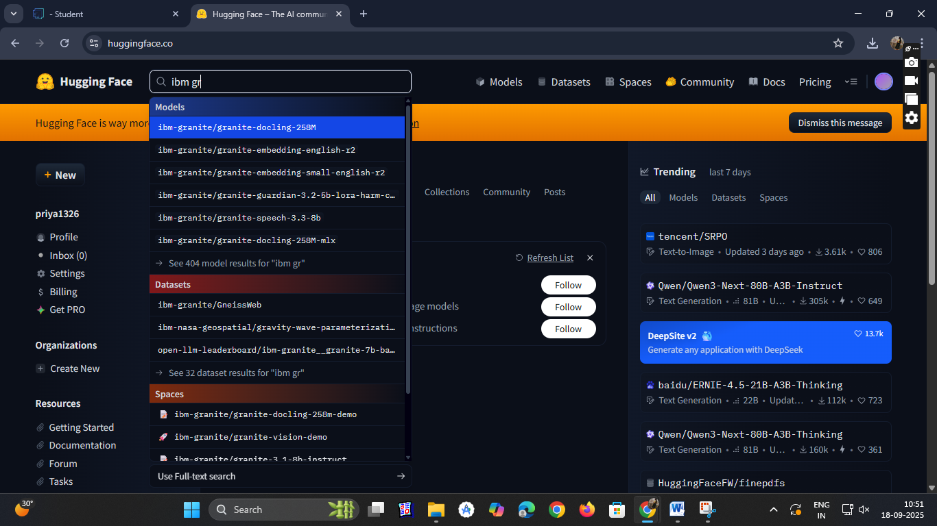

● Here for this project we are using “granite-3.2-2b-instruct” which is compatible fast and light weight.

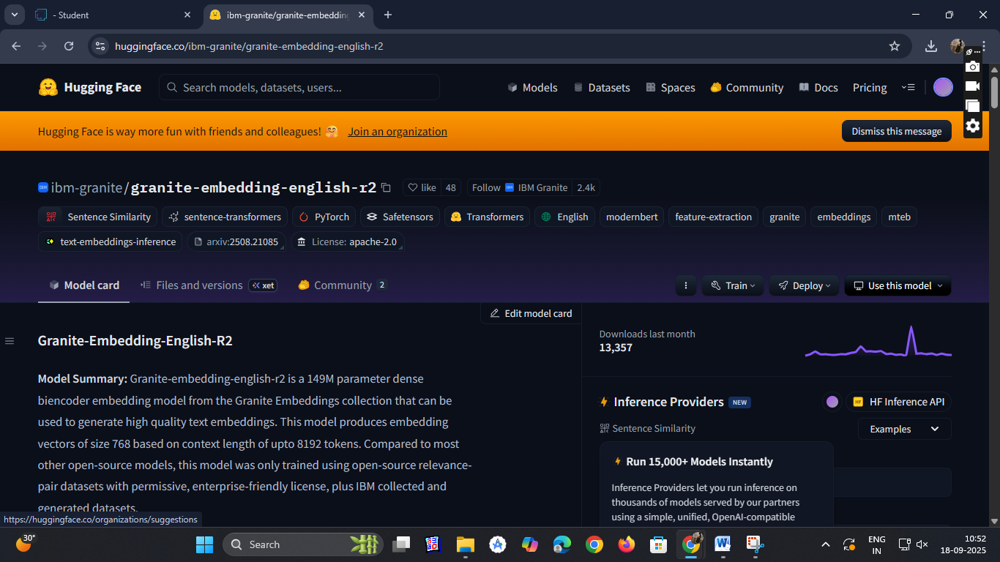

● Now we will start building our project in Google collab.

Activity-3: Running Application in Google Collab.

● Search for “Google collab” in any browser.

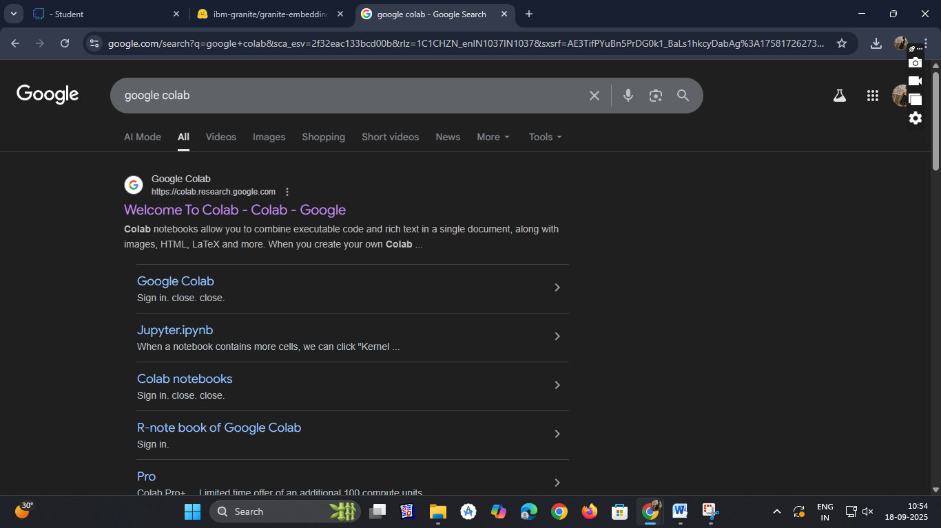

● Click on the first link (Google Colab), then click on “Files” and then “Open Notebook” then Click on “New Notebook”

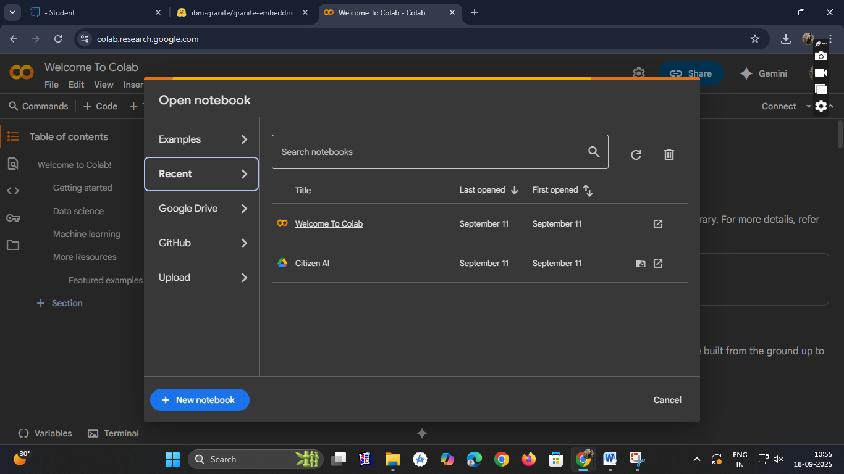

● Change the title of the notebook “Untitled” to “Citizen AI”. Then click on “Runtime”, then go to “Change Runtime Type”.

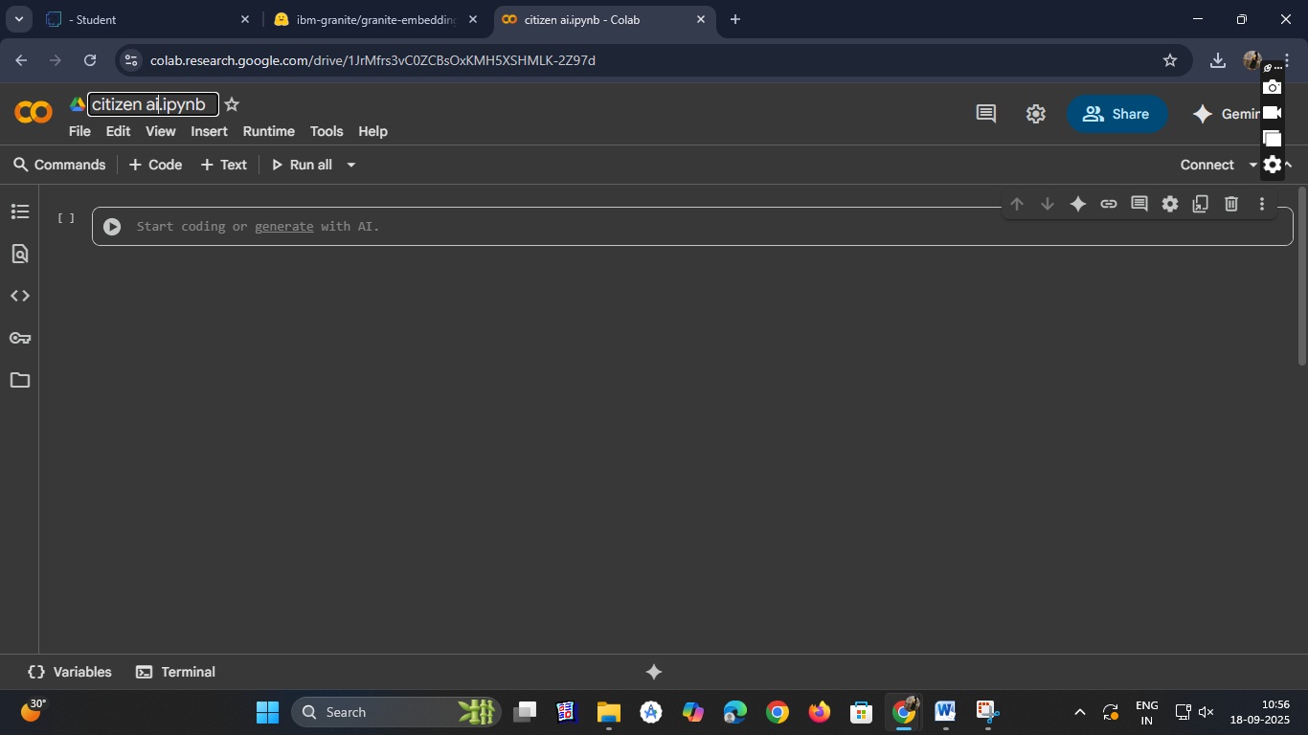

● Choose “T4 GPU” and click on “Save”

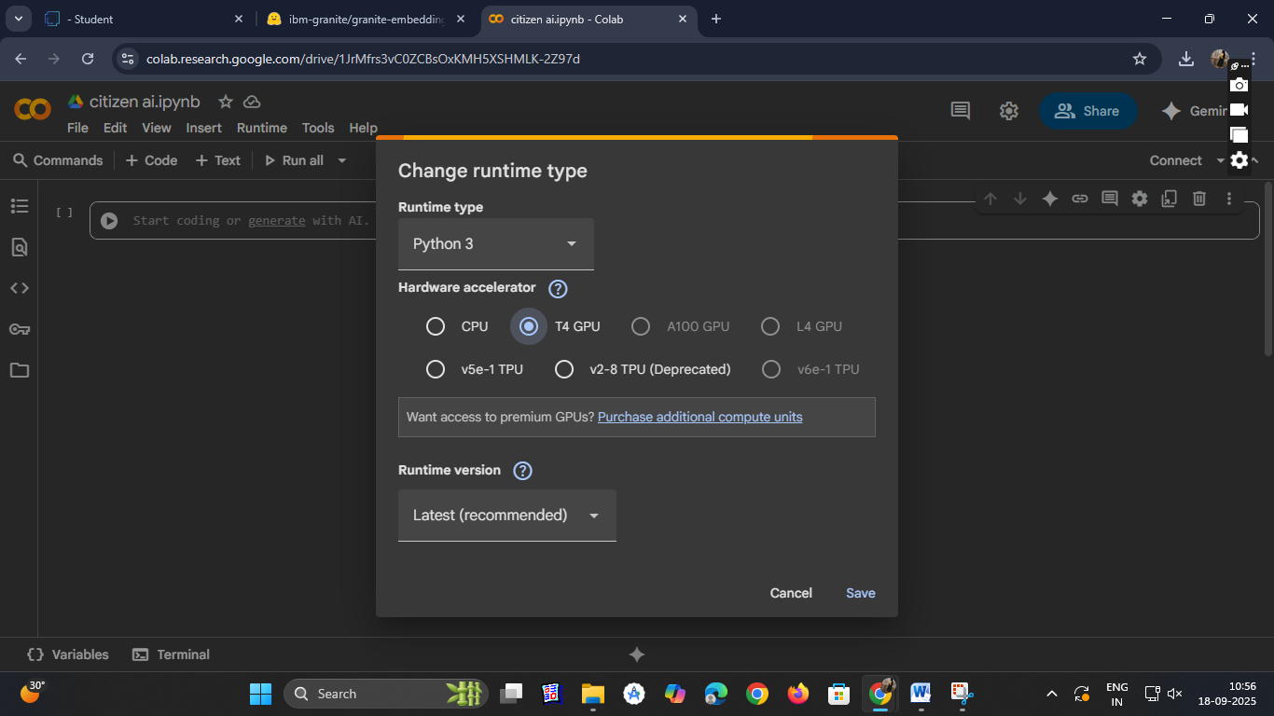

● Then run the rest of the code in the next cell.

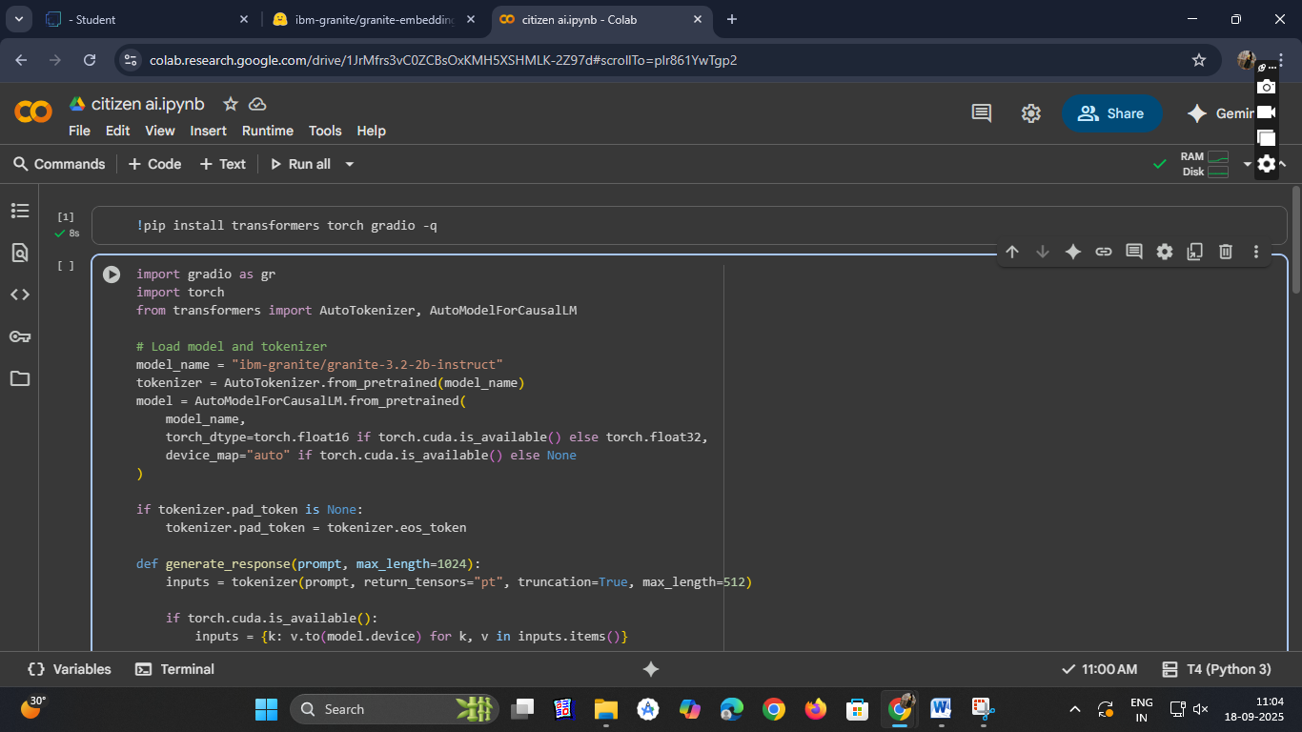

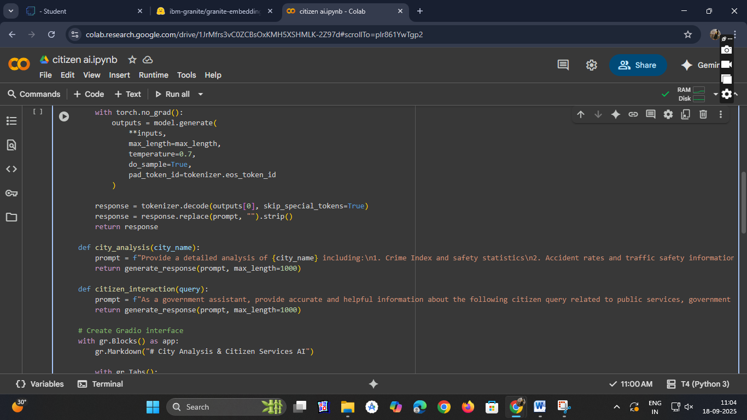

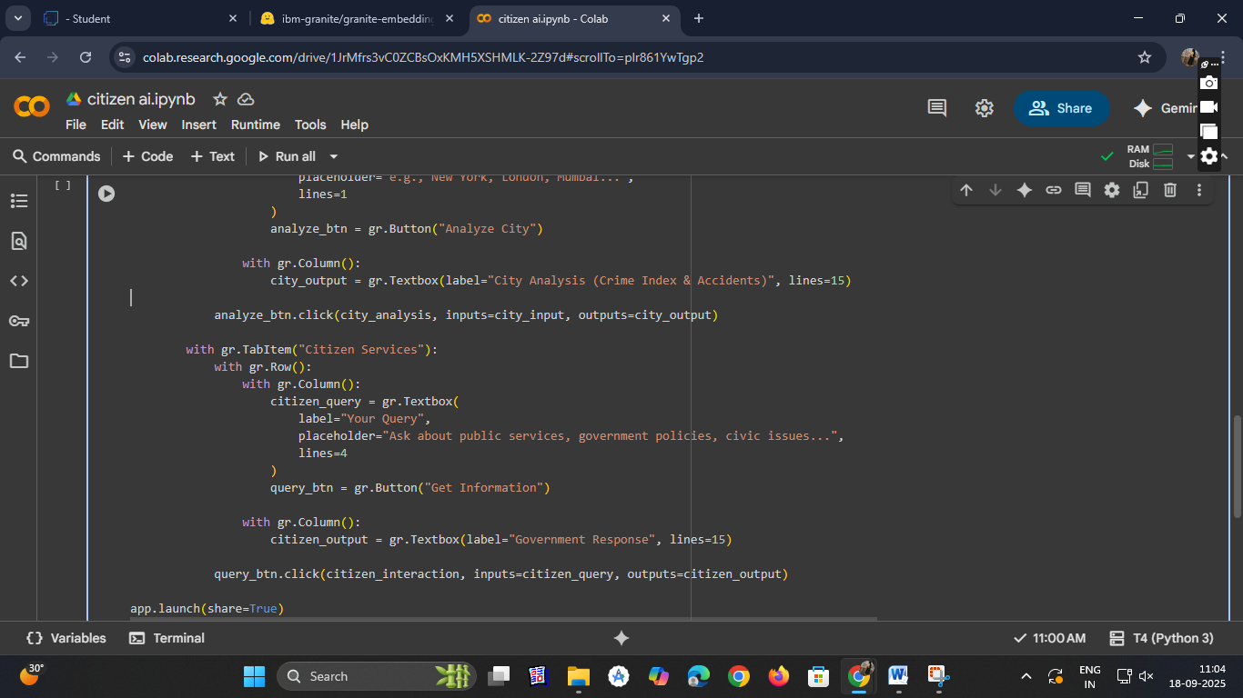

● You can find the code here in this link: CitizenAI Code

OUTPUT:

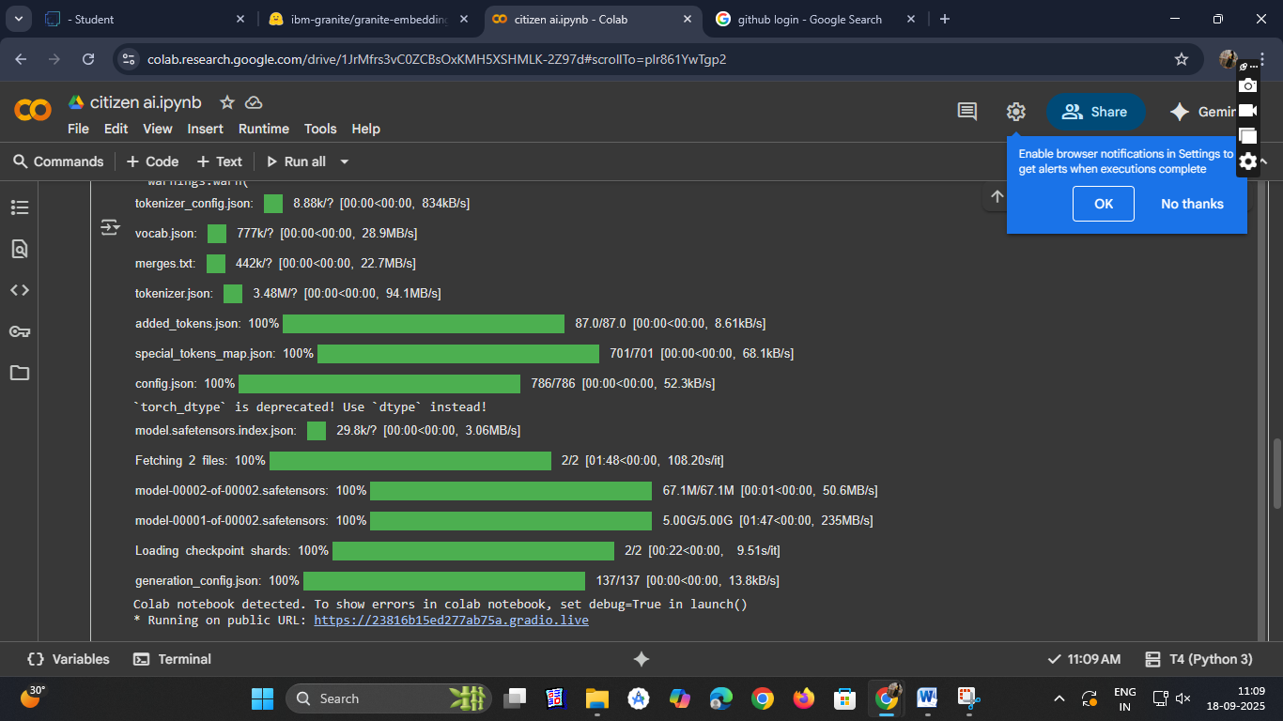

● Now you can see our model is being Downloaded and application is running

Colab notebook detected. To show errors in colab notebook, set debug=True in launch ()

*Running on public URL : https://23816b15ed277ab75a.gradio.live

● Click on the URl to open the Gradio Application click on the link

● You can View the Application is the running in the other tab.

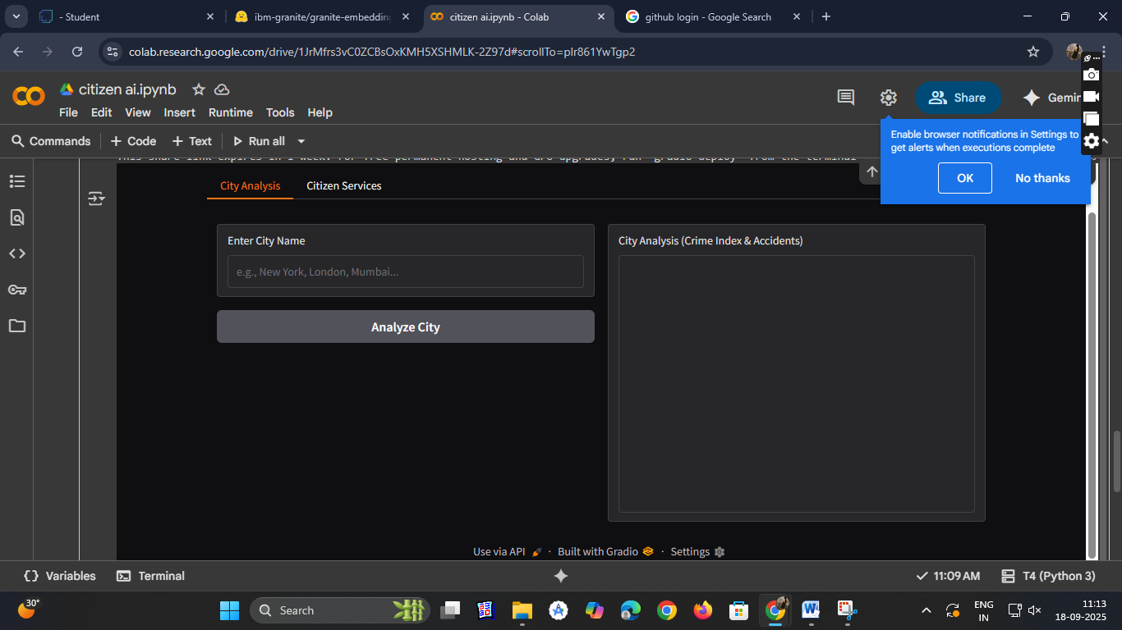

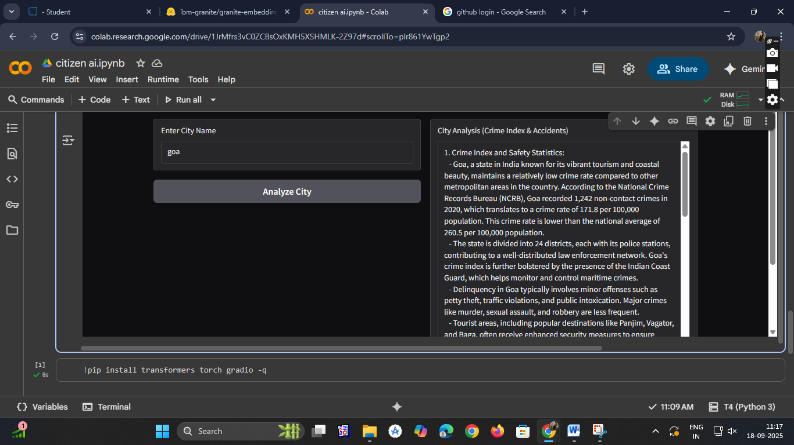

Activity-4: Upload Your Project in GitHub.

● Search for “GitHub” in any browser, then click on the first link ([GitHub](https://github.com/)).

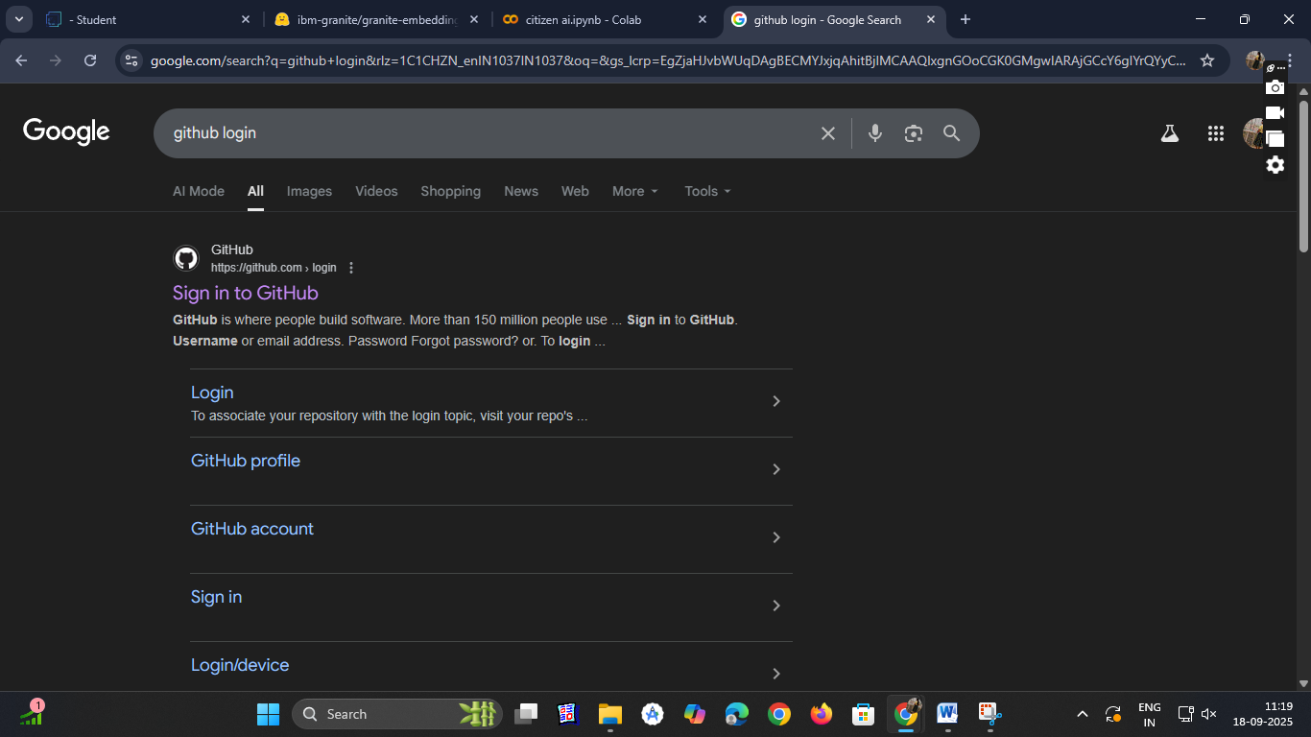

● Then click on “Signup” and create your own account in GitHub. If you already have an account click on “Sign in”.

● Click on “Create repository”.

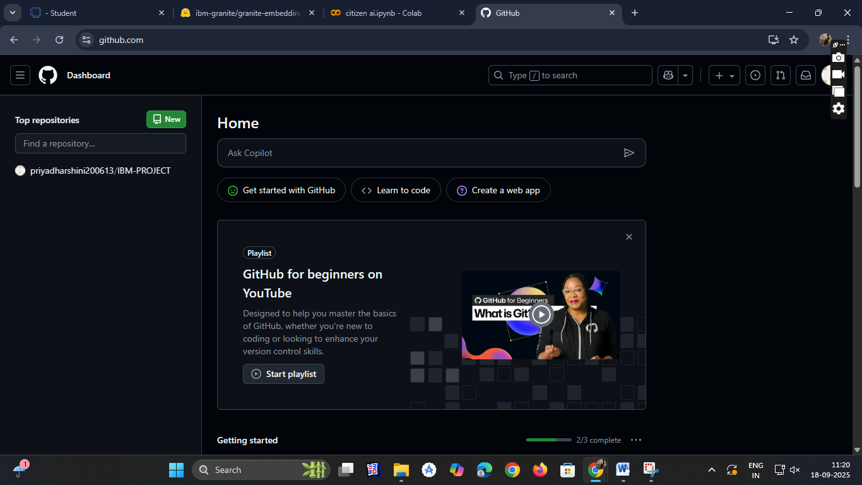

● In “General” Name your repo. (Here I have given “IBM-Project” as my repo name and it is available)

● In “Configurations” Turn On “Add readme” file Option.

● Now Download your code from Google collab by Clicking on “File”, then Goto “Download” then download as “. Py ”.

## 

● Then your repository is created, then Click on “Add file” Option. Then Click 15 “Upload files” to upload your files.

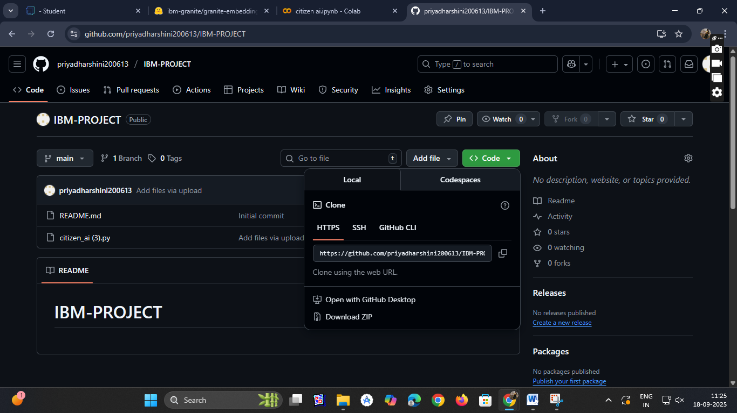

● Click on “choose your files”.

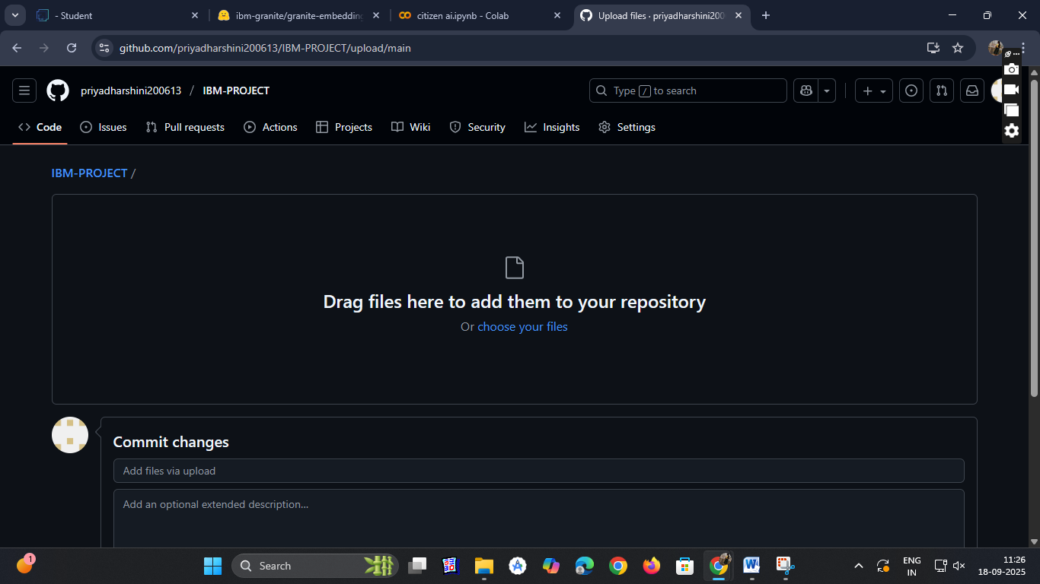

● Choose your project file and click on “Open”.

● After your file has Uploaded Click on “Commit changes”.

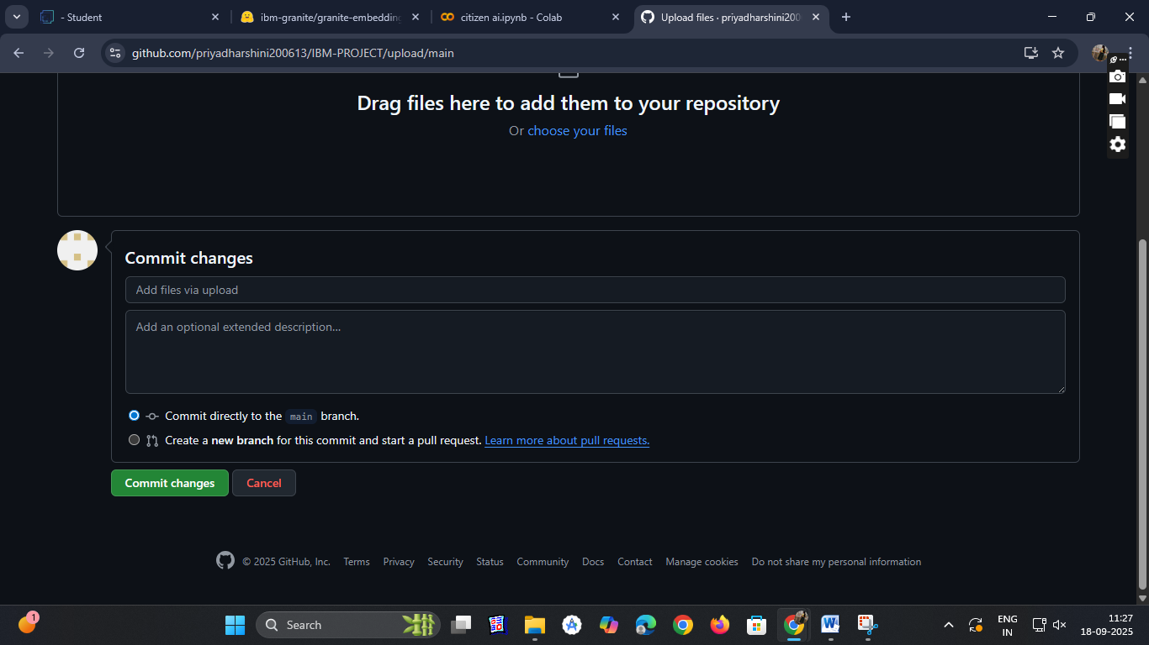

**CONCLUSION:**

The Citizen AI – Intelligent Citizen Engagement Platform demonstrates the power of integrating modern AI tools and collaborative platforms to enhance public service delivery and civic engagement. By leveraging the Naan Mudhalvan Smart Internz portal for skill development and collaboration, Hugging Face for deploying advanced NLP models, Google Colab for real-time experimentation and model training, and GitHub for version control and project management, we created a robust and scalable solution aimed at improving how citizens interact with government services. This project not only showcases the practical application of AI in governance but also highlights the importance of interdisciplinary learning and open-source collaboration in building impactful, citizen-centric technologies.